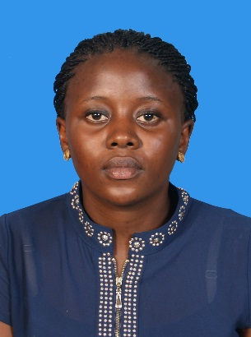

**ZOKTI CHONGCHIMEL GLAD**

**BLOCK C-3-54B, Jalan SP 5/4 Seksyen 5, Taman Serdang Perdana.**

Date of Birth: 31-October-1994

Gender: Female

Email: chimel_zokti@yahoo.com

Phone No: +60108329175

**EDUCATION**

* **Universiti Putra Malaysia, Selangor**

**BSc. in Human Resource Development [**Expected Year of Graduation 2018**]**

**Area of Study:** Major in Human Resource Development.

**CGPA: 3.082**

* **Ahmadu Bello University Zaira, Nigeria**

A’LEVEL

* **Baptist Model High School U/Boro Kaduna, Nigeria**

O’LEVEL, NECO

**TECHNICAL SKILLS**

**Computer Skills:** Microsoft Word, Excel, PowerPoint

**Software Packages:** Mendeley, Corel draw

**SKILLS**

* Ability to work u under pressure with no supervision
* Excellent interpersonal and communication Skill
* Ability to work effectively in a team
* Youth Development
* Staff Supervision
* Basic Entrepreneurship
* Career Development
* Self-motivated and target oriented
* Human Resource Theories and Practice

**EXPERIENCE**

Community service in Negeri Sembilan, Semester 1 2015/2016.

Position of the labour prefect for 2years in high school.

Head of cultural club for 6years in high school.

**AWARDS/ACTIVITIES**

* Alethic 100metres 3rd position
* Matron race first female
* 200metres 2nd position

**HOBBIES:**

* Reading, singing, and playing games

**CAREER OBJECTIVE**

* To gain excellent experience as a human resource officer to help achiever a successful career in future, to attain high achieve as an HR practitioner.

**REFERENCE**

Prof. Madya Dr. Bahaman Abu Samah Universiti Putra Malaysia +603-89468231 [bas@upm.edu.my](mailto:bas@upm.edu.my)

Dr Mohd Mursyid Arshad Universiti Putra Malaysia (603) 8946 7902

[m_mursyid@upm.edu.my](mailto:m_mursyid@upm.edu.my)